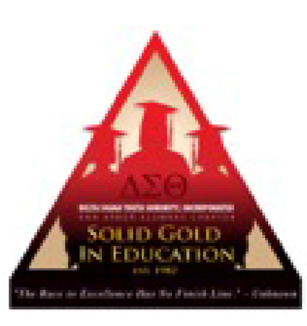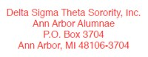
WCC Book Scholarship Guidelines & Application

Delta Sigma Theta Sorority Inc., Ann Arbor Alumnae Chapter is pleased to provide a book scholarship designated for women enrolled in Washtenaw Community College (WCC) who fall in the category of “non-traditional student”. This award is supported by private donations and available to the selected applicant(s) meeting the following requirements:

▪ Non-Traditional Student
▪ African-American Female
▪ G.P.A. 2.0 or higher
▪ Completed a minimum of 12 college credit hours
▪ No prior Bachelor’s Degree & has exhibited financial need

Attached is an application form that may be forwarded as you deem appropriate. Please note that in addition to the eligibility criteria above, applicants are required to submit:

▪ One photo
▪ A completed, typed application form including a one page essay
▪ A transcript including current grade point average
▪ Two letters of recommendation from non-family members, one of which must be from a WCC Academic Advisor/Counselor. Each letter should include:
- The length of time you have known the applicant
- A description of the applicant’s attributes and characteristics
- An explanation of why you believe the applicant has the perseverance to succeed at the college/university level

All application information should be emailed to:

Cheryl Finley, Case Manager/Student Advisor
Crfinley@wccnet.edu
Student Resource Center
Washtenaw Community College
Department of Counseling & Career Planning

Application packet must be received by April 30, 2022

All applications will be reviewed by the WCC Student Resource Center. If you have any questions, please contact Cheryl Finley, WCC Student Resource Center, at (734) 489-9688. Thank you for assisting us in this important endeavor.

Tomica Stone, PRESIDENT
M. Elaine Kinloch, SCHOLARSHIP COMMITTEE CHAIR
Cheryl Finley, WCC SCHOLARSHIP LIAISON

Personal Information | TO BE COMPLETED BY STUDENT
Full Name
Street Address
City & ZIP Code
Phone Number(s)
Email
WCC Student ID #

WCC Information | TO BE COMPLETED BY COUNSELOR
Applicant’s Overall GPA
Declared Major
Anticipated Date of
Graduation
Counselor/Advisor
Information
Name & office phone number

Employment | STUDENTS: PLEASE LIST ALL PAID POSITIONS
Company/Location | Dates of employment | Responsibilities

STUDENTS: PLEASE DO NOT EXCEED 250 WORDS. YOU MAY
Essay SUBMIT THE TYPED, DOUBLE SPACED ESSAY IN
THE SPACE BELOW OR ON A SEPARATE SHEET OF PAPER.
Topic: “What would receiving the Delta Sigma Theta Sorority Book Scholarship Mean to Me”

Letters of  Recommendation | PLEASE PROVIDE INFORMATION FOR THE INDIVIDUALS WHO  HAVE PROVIDED A LETTER OF RECOMMENDATION ON YOUR BEHALF.
Name | Occupation | Relationship to Student | Contact Information
 |  |  | ( Ph o n e )
 |  |  | ( Em a i l )
 |  |  | ( Ph o n e )
 |  |  | ( Em a i l )

Signatures
“I hereby certify that the information provided herein is accurate and current. I understand that this application packet will be kept confidential and all materials submitted become the final property of the
Ann Arbor Alumnae Chapter of Delta Sigma Theta Sorority, Incorporated.”
Applicant Signature
WCC Counselor Signature

ALL OF THE ITEMS LISTED BELOW MUST BE INCLUDED IN
YOUR PACKET IN ORDER FOR THIS APPLICATION TO BE
Checklist CONSIDERED. PLEASE VERIFY THAT YOU HAVE SUBMITTED THE FOLLOWING:
⬜ | Completed, typed application form
⬜ | Transcript
⬜ | Two (2) letters of recommendation from non-family members
⬜ | Photo
⬜ | Typed, one-page essay on the topic provided
⬜ | Original signatures of student and WCC counselor on application
⬜ | Signed Photo/Video release form

Photograph/Video Authorization and Release Form
I, _______________________________________, give permission for the Ann Arbor Alumnae
Chapter of Delta Sigma Theta Sorority, Incorporated (the “Chapter”) to publish on the Internet or media still photographs or moving images, including (if applicable) any sound recordings accompanying the images (“Images”) taken of me at Scholarship/solid Gold award activities without payment or any consideration and without notifying me.

I understand and agree that these Images will become the property of the Chapter, which shall have complete ownership of the Images. I hereby irrevocably authorized the Chapter to publish or distribute these Images for the purpose of publicizing the Chapter’s scholarship programming and for any other lawful purpose. In addition, I waive any right to inspect or approve the finished product wherein my likeness appears. Additionally, I waive any rights to royalties or other compensation arising out of or related to the use of the Images.

I hereby hold harmless and release and forever discharge the Chapter and any of its officers and members; Delta Sigma Theta Sorority, Incorporated; its officers; National Executive Board; employees; members; representatives; agents; and assigns from any and all claims, costs, suits, actions, judgments, and expenses which I, or any other persons acting on my behalf have or may have by reason of the use of the Images. This release specifically includes, without limitation, a complete release and discharge of any liability by virtue of any editing, distortion, alteration, or optical illusion, whether intentional or otherwise, that may occur or be produced in the taking of or editing of said Images, unless it can be shown that such was maliciously caused, produced and published solely for the purpose of subjecting my child to conspicuous ridicule, scandal, reproach, scorn and indignity.

Signature
Date

